Project Group No.- 14

Article On -

**Flexible Fuel Vehicles**

Flexible fuel vehicles (FFVs) have an internal combustion engine and are capable of operating on gasoline and any blend of gasoline and ethanol up to 83%. FFVs have one fuel system, and most components are the same as those found in a conventional gasoline-only car. Some special ethanol-compatible components are required to compensate for the different chemical properties and energy content in ethanol, such as modifications to the fuel pump and fuel injection system. The engine control module (ECM) is also calibrated to accommodate the higher oxygen content of ethanol.

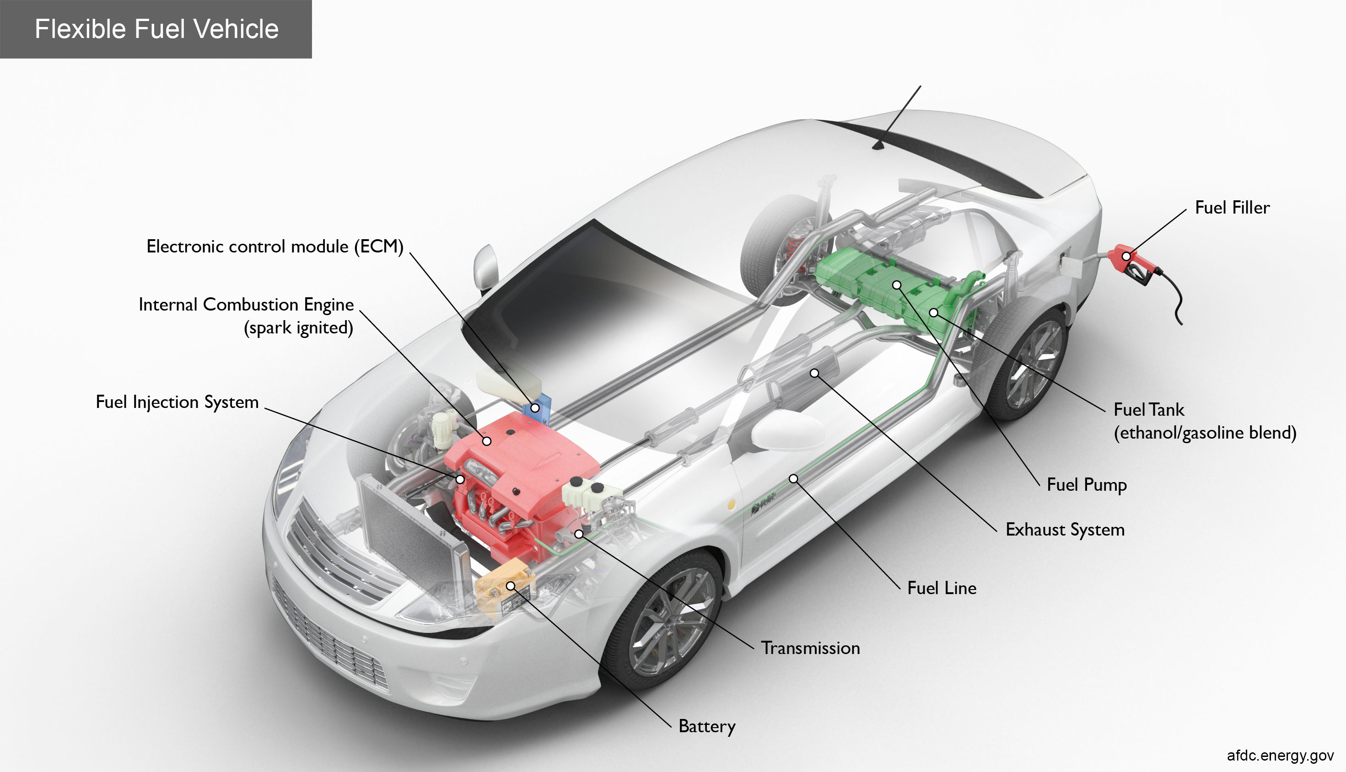

Key Components of a Flex Fuel Car

**Battery**: The battery provides electricity to start the engine and power vehicle electronics/accessories.

**Electronic control module (ECM)**: The ECM controls the fuel mixture, ignition timing, and emissions system; monitors the operation of the vehicle; safeguards the engine from abuse; and detects and troubleshoots problems.

**Exhaust system:** The exhaust system channels the exhaust gases from the engine out through the tailpipe. A three-way catalyst is designed to reduce engine-out emissions within the exhaust system.

**Fuel filler:** A nozzle from a fuel dispenser attaches to the receptacle on the vehicle to fill the tank.

**Fuel injection system:** This system introduces fuel into the engine's combustion chambers for ignition.

**Fuel line**: A metal tube or flexible hose (or a combination of these) transfers fuel from the tank to the engine's fuel injection system.

**Fuel pump:** A pump that transfers fuel from the tank to the engine's fuel injection system via the fuel line.

**Fuel tank (ethanol/gasoline blend):** Stores fuel on board the vehicle to power the engine.

**Internal combustion engine (spark-ignited):** In this configuration, fuel is injected into either the intake manifold or the combustion chamber, where it is combined with air, and the air/fuel mixture is ignited by the spark from a spark plug.

**Transmission**: The transmission transfers mechanical power from the engine and/or electric traction motor to drive the wheels.

Benefits:

FFVs are aimed at reducing the use of polluting fossil fuels and cutting down harmful emissions.

Alternative fuel ethanol is Rs 60-62 per litre while petrol costs more than Rs 100 per litre in many parts of the country, so by using ethanol, Indians will save Rs 30-35 per litre.

For India, FFVs will present a different advantage as they will allow vehicles to use different

blends of ethanol mixed petrol available in different parts of the country.

Since India has surplus produce of corn, sugar and wheat, the mandatory blending of ethanol programme will help farmers in realising higher incomes.

For the overall Indian economy, higher usage of ethanol as an automobile fuel will help save import costs as the country meets more than 80 per cent of its crude oil requirements through imports.

Disadvantages/challenges of using FFVs:

Customer acceptance will be a major challenge since the cost of ownership and running cost are going to be very high compared with 100 per cent petrol vehicles.

Running cost (due to lower fuel efficiency) will be higher by more than 30 per cent when run with 100 per cent ethanol (E100).

Flex Fuel Engines cost more as ethanol has very different chemical properties than petrol. Ethanol has very low (40 per cent) Calorific value as compared to Gasoline, very High Latent heat of vaporization causing cooling of charge/combustion etc.

Ethanol also acts as a solvent and could wipe out the protective oil film inside the engine thereby could cause wear and tear.

Source

1.https://afdc.energy.gov/vehicles/how-do-flexible-fuel-cars-work

2.https://www.insightsonindia.com/2021/07/12/govt-to-issue-guidelines-for-flex-fuel-vehicles/

Group members-. Roll No.

1. Tejas Somnath Brahmankar. 24
2. Yash Rajesh Chopda. 34
3. Siddharth Nitin Joshi. 58
4. Rohit Ashok Shirode. 131